6. Compare searches:
Best first search was typically fast (i.e. expanded few nodes), but also produced the least optimal results. A* search always had the optimal solution, but sometimes expanded more nodes than best-first search. Uniform-cost search also always had the optimal solution, but expanded the most nodes by far (since it expands nodes blindly). A* with an inadmissible heuristic performed better than best-first search, but worse than A* or uniform-cost. This is likely because it often chooses the “best” next solution (since the heuristic was 100*h(n)) – leading it to act more like best-first search.

Potential Fields – sphereWorld1.xml

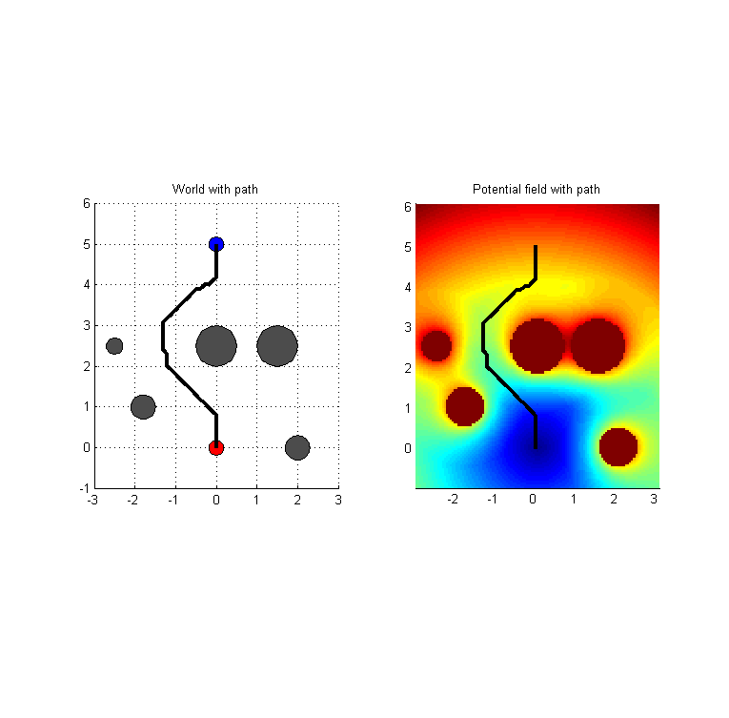

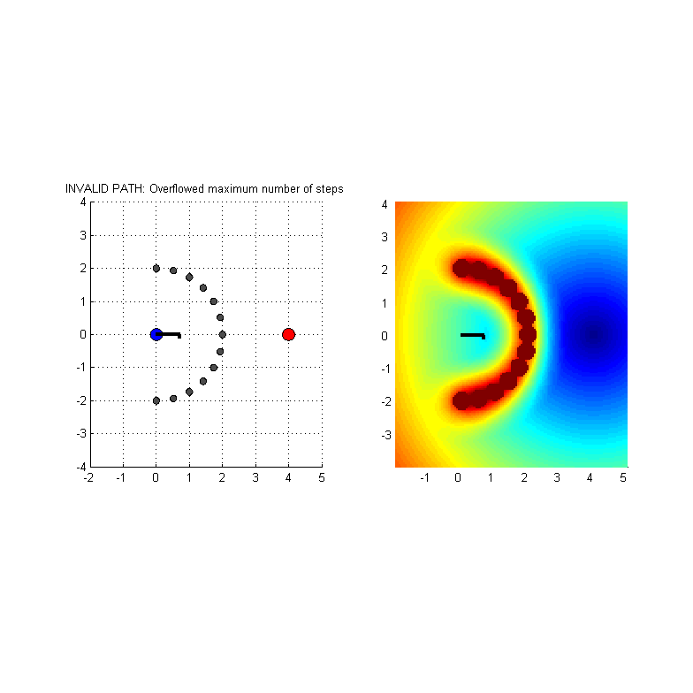
Potential Fields – sphereWorld2.xml

PRM search – sphereWorld1.xml
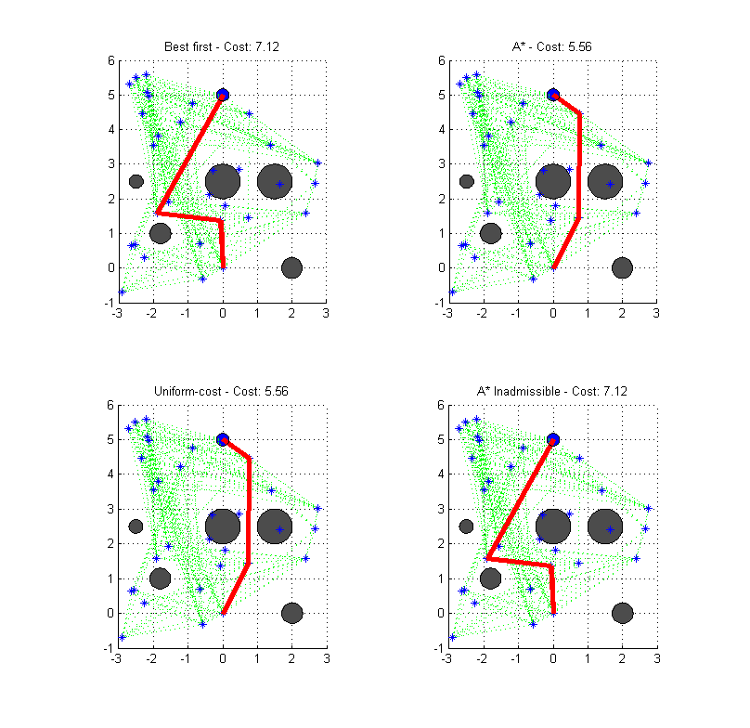

PRM search – sphereWorld2.xml
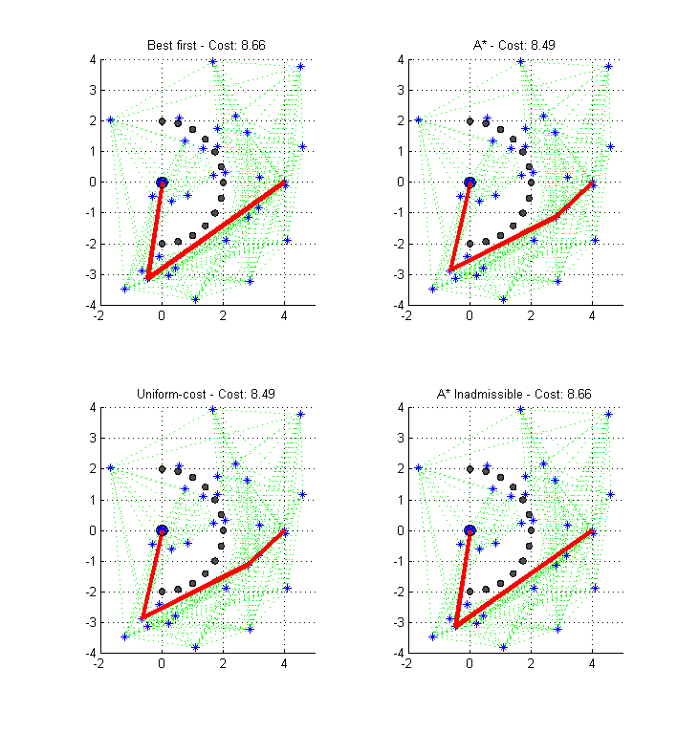

PRM search – sphereWorld3.xml
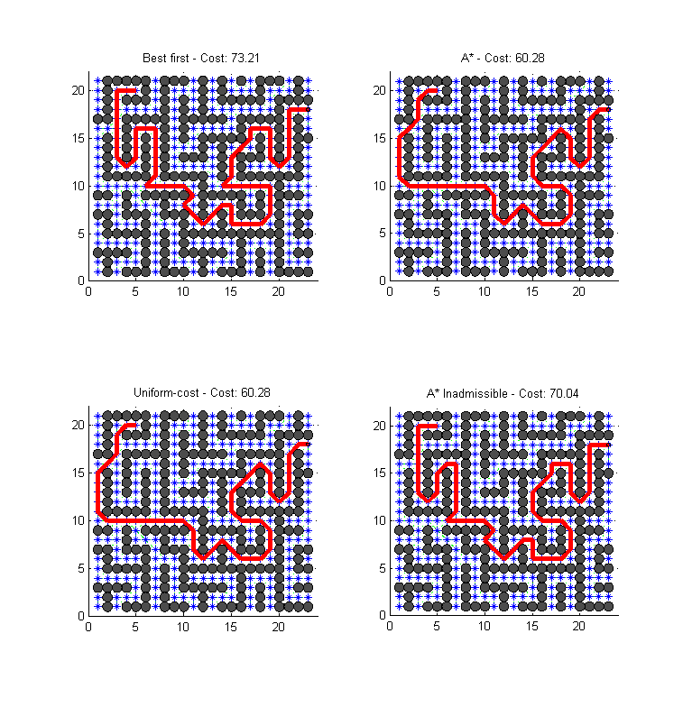

PRM search – armWorld1.xml

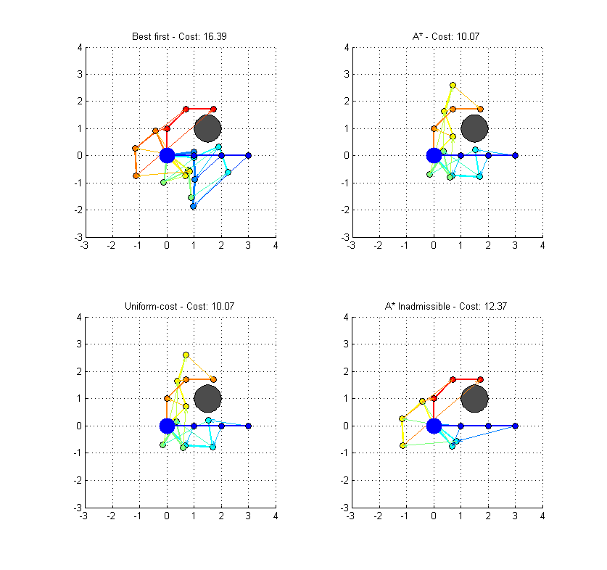

PRM search – sphereWorld2.xml

